

How to do keyword research for content creation

Aim & Scope  Guide content creators through systematic keyword research that balances search demand, ranking potential, and business objectives. | Background  This methodology uses structured brainstorming, competitive analysis, and Ahrefs data to build comprehensive keyword lists that align search intent with content goals. The template-based process ensures consistent, data-driven keyword selection across different content types.

Responsibilities

Project manager  The person is responsible and accountable to the client for the copywriting service.  - Liaises with the client and handles all communication with internal team members.  - Assign a copywriter to the task, brief them, and ensure you share all relevant information with the writer.  - Oversees any Asana tasks and ensures tasks are completed on time and within budget. | Copywriter  The person is responsible for writing the copy.  - Responsible for completing the writing task detailed in this SOP on time and on budget.  - Ensure the project manager is updated on the progress and make them aware of any roadblocks immediately.  - Ensure any relevant Asana tasks are kept up to date, are within the time range, and completed in time.  - Ensure document links are reviewed accordingly, readily available, and shared.

Prerequisites & TOC

Templates you need  - Keyword research template  Tools you need  - Surfer logins  - Ahrefs logins  - Tools required: Ahrefs, Google Search Console, Keyword Research Template, SurferSEO  - If a content audit has been completed, use it. | Table of contents  How to do keyword research for content creation  Step 1: Document Setup  Step 2: How to find seed terms  Step 3: Creating your brainstorm list of terms  Optional Step: Peer Review Brainstormed List Of Keywords  Step 4: Exporting the data  Step 3: Analysing terms & using filters  Step 4: Exporting SERP examples for focus terms  Step 5: Peer review of keyword research during the outline review phase  End of SOP

Step 1: Document Setup

Copy the Keyword Research Template
  - Open the keyword research template link to make a copy.
  - Rename the document: Blog Topic/Landing Page Title - {Client name}.
  - Save in the correct folder, enabling appropriate sharing settings (Woww 4 - Clients, client-specific subfolder, content creation, landing pages/blog posts).

Step 2: How to find seed terms

How to find seed terms

Refer to the briefing materials for the project
Thoroughly review project documents to extract key information and insights.

When examining briefing materials, consider the following:

- Any content strategy/content audit that has been developed/conducted
- Any specific goals or focus areas of the project
- The client's unique selling propositions (USPs) and KPIs (revenue, purchases, sign-ups, form submissions etc.)
- Target audience demographics and location
- Core product/service offerings and their features
- Positioning in the market/niche

- Google searches

  - Brainstorm some terms related to the topic you are writing on and test them by Googling them in Incognito mode.
Take note of the search results returned to determine whether they are relevant to the positioning of the company and the content you are writing about.
- For example, if the SERP is informational and you are writing a blog, the terms may be relevant and useful.
- For example, if the terms are service/product/solution-focused, and you are creating content for landing pages, then the terms may be relevant and useful.
  - If the roles above are reversed, then issues may be flagged with your brainstorming list (search intent not matching the approach/intent of your content).
  - There are exceptions, such as informational terms that may fall part of LSI/supporting terms included in the body content of a landing page.

You can also look at “people also ask” to find some additional longtail keywords that can be added to your brainstorming list.

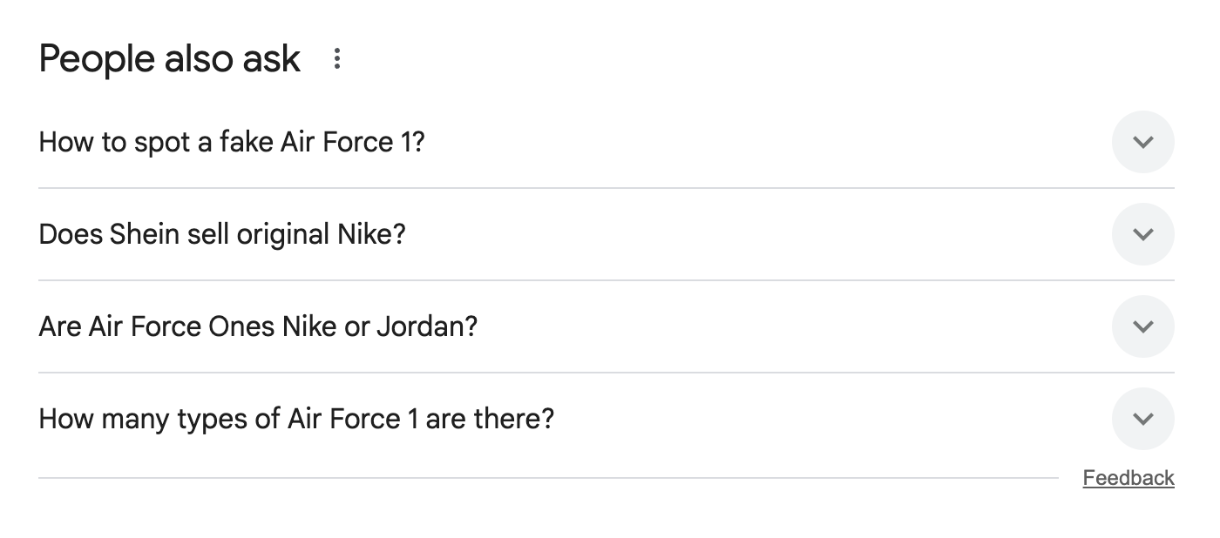

- Ad hoc Ahrefs searches in Keywords Explorer

When you have validated the positioning/intent of a handful of keywords in your brainstorming list, you can perform test searches using them in Ahrefs Keywords Explorer.

This will reveal additional keyword variations and related terms in the matching terms report that you may have missed during brainstorming.

Copy relevant keywords from these results and add them back to your brainstorming list for a comprehensive export.

Inputting URLs into Site Explorer to find competitor page rankings

When conducting Google searches, you may come across websites/competitors with similar/overlapping offerings with your client.

You can copy the URL of a page that is ranking for a term you wish to rank for and use Site Explorer (remember to select “exact URL”) to explore/see all of the keywords that the page currently ranks for.

Example:

This may enable you to find additional keywords or variations you can target.

*Remember to set the location correctly (to the region you’re targeting).

Step 3: Creating your keyword brainstorm list

- Use the brainstorming tab within the keyword research template to create your list.
-
This section covers how to set up and lay out your sheet; you will also need to refer to this step to understand the variations of terms you need to write down/brainstorm.
-
Navigate to the brainstorming tab within the keyword research template before you read the rest of the instructions.

Modifier + Base Phrase

From B3 to F14, the formula used in each cell combines a term in column A with the first row’s term in each column.

I.e: the formula in cell B3 is “ =$A3&" "&B$1 ” (modifier + base phrase)

=$A3&" "&B$1 combines the value in column A, row 3, with the value in row 1, column B, separated by a space.

- Column A (Modifiers/Descriptors): These are adjective or feature-based words that describe or modify the core phrase.
Examples: French press, manual.
  - $A3: The column (A) is fixed with $, meaning if you copy the formula across columns, it will always refer to column A. The row (3) is relative, so it updates when copied to different rows.
- Row 1 (Base Phrase): This is the main keyword or product, typically a noun or core topic you're targeting.
We highlight the base phrase in the following example: coffee machine, coffee system, coffee pot, coffee brewer.
  - B$1: The row (1) is fixed with $, so if you copy the formula down, it always points to row 1. The column (B) is relative and will change if copied across columns.

Base Phrase + Modifier
From B21 to F31, the formula used adds a term in column A to the end of a term in the first row of a column.
I.e: the formula in cell B21 is “ =B$1&" "&$A21 ” (base phrase + modifier)
- Column A (Modifiers/Descriptors): These are adjective or feature-based words that are appended to the end of the base phrase.
Examples: with grinder, for small kitchen, for small office.
- Row 1 (Base Phrase): This is the main keyword or product, typically a noun or core topic you're targeting.
We highlight the base phrase in the following example:: coffee machine, coffee system, coffee pot, coffee brewer.

Flatten terms within a range into a single column.
This will help you easily collate a list of terms so you can copy them into Ahrefs.
Column O uses the formula =FLATTEN to collect the list of terms in the range B3 to N19.
- If you expand the range (B3:N19) and need to list more terms, remember to update the range specified for the FLATTEN formula in cell O3.
Column P uses the formula =FLATTEN to collect the list of terms in the range B21 to N146.
- If you expand the range (B21:N146), and need to list more terms, remember to update the range specified for the FLATTEN formula in cell P3.

Here is an example of a brainstormed list
Here are terms you might consider brainstorming if you are targeting consumers who are looking for types of coffee machines.
Coffee Maker - Keyword Research Example

Write a list of relevant terms to input into Ahrefs

To write your list, start with a single keyword and keep in mind the considerations noted below for each word.

2.1 Singular & plural forms

Include both singular and plural forms of terms.
- Examples:
  - coffee maker
  - coffee makers
2.2 Common synonyms and closely related terms
Include widely used alternative terms that the general public might use interchangeably.
- Examples:
  - coffee machine
  - coffee brewer
  - coffee pot
  - coffee system
2.3 Spelling variations
Account for common spelling differences or variations
- Examples:
  - coffee maker
  - Coffeemaker
2.4 Industry recognised terminology
Include specialised terms used by enthusiasts or professionals in the field
- Examples:
  - drip coffee machine
  - pour over coffee maker
  - French press
  - espresso machine
2.5 Intent-focused terms
Brainstorm keywords based on different user intents and stages of the buyer's journey
Informational  - Keywords used by people seeking information or education how to use a coffee maker  - coffee maker reviews | Transactional:  Keywords used by people ready to make a purchase  - buy coffee maker  - coffee maker sale  - cheap coffee makers
Service-focused:  Keywords related to maintenance or support for the product  - coffee maker repair  - coffee maker cleaning service | Solution-focused:  Keywords addressing specific needs or problems  - coffee maker for small kitchen  - quick brew coffee maker  - thermal carafe coffee machine  - compact espresso machine for RV camping

Feature-focused

Keywords containing phrases that relate to features of a given product or service.
- programmable coffee maker
- single-serve coffee maker
- coffee maker with grinder
- wifi-enabled smart coffee maker with mobile app control

Additional considerations when brainstorming terms
Here are some additional considerations; however, please remember that you may not need to utilise some of the considerations below when creating your list of seed terms.
The reason these additional considerations may not be necessary is that your brainstormed list of seed terms will be input into Ahrefs. You can export hundreds/thousands of matching terms and questions, and you can apply filters to the data in sheets to obtain the below.
Negative keywords  Identify terms you want to exclude from your targeting  Examples:  - free coffee maker (if you don't offer free products)  - coffee maker parts (if you only sell complete units)  - commercial coffee machines (if you focus on home use) | Comparative keywords  Comparing solutions/services/products or brands in a niche.  Examples:  - drip coffee maker vs. French press  - Keurig vs. Nespresso  - manual vs. automatic coffee machine
Question-based keywords  Incorporate common questions users might ask related to your product  Examples:  - What's the best coffee maker for a small office?  - How often should I clean my coffee machine?  - Can you make espresso with a regular coffee maker? | Brand-specific terms  Include popular brand names and their product lines  Examples:  - Keurig coffee maker  - Nespresso machine  - Mr. Coffee brewer

Seasonal and temporal variations

Account for how search behaviour changes over time or during specific periods

Examples:
- summer iced coffee maker
- holiday gift coffee machine
- Black Friday coffee maker deals

Universal modifiers you can try when brainstorming keywords

When brainstorming keyword variations, adding proven modifiers to your base terms can help uncover high-intent opportunities and more nuanced queries. These modifiers apply across industries and work well for SEO and paid search insights.

Informational modifiers:
These help capture users in the awareness and research phase. Examples:
what is, how to, guide, tips, ideas, benefits, checklist, tutorial, examples.

Comparative modifiers:
Often used to weigh up options. Examples:
vs, comparison, alternatives, better than, difference between, pros, cons.

Transactional/Commercial modifiers:
These signal readiness to take action (purchase, sign up, enquire). Examples:
best, top, buy, cheap, affordable, online, near me, free trial, for sale, pricing, cost, review.

Use-case or audience modifiers:
Tailor to different needs or customer types. Examples:
beginners, small business, home, kids, professionals, ecommerce, etc.

Optional Step: peer review brainstormed list of keywords
If you need a sanity check on your list of terms (if you are unsure whether they align with the blog post or the page you are creating content for), before you copy them into Ahrefs and export the data, you can request a review at this stage by creating and assigning a peer review task.
In the task you’ve created, add a link to your keyword research sheet and ensure that the team member reviewing it has access to the sheet.

Otherwise, proceed to export the data (step 4 below).

Step 4: Exporting the data

Open your keyword research sheet and Ahrefs
Open your keyword research sheet and navigate to the keywords explorer in Ahrefs. Paste your flattened list of terms, set the region (e.g., South Africa) and click “search”.
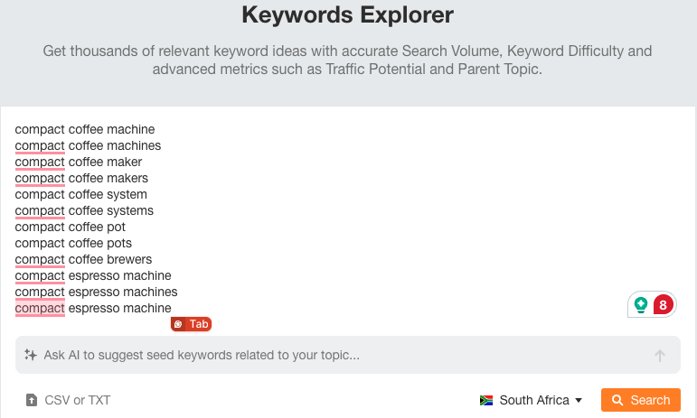

Overview tab
Export the data from the overview tab.

Select “all” and “CSV (UTF-8, Best for Excel)”.
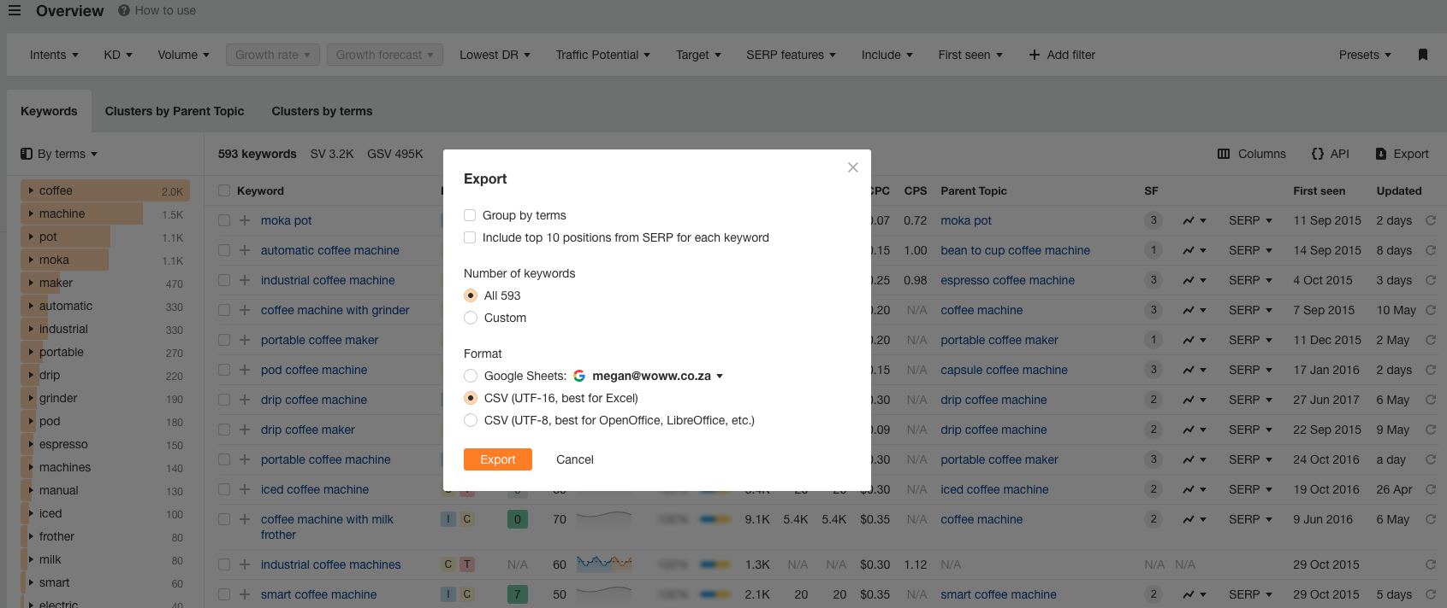

Matching tab
Click on the “matching” tab and export matching terms.
You can use up to 1000 rows or export all terms depending on your needs.

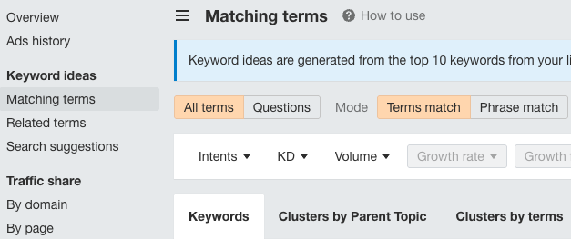

Questions tab
Click on the “questions” tab to export the keywords that fall under this tab.

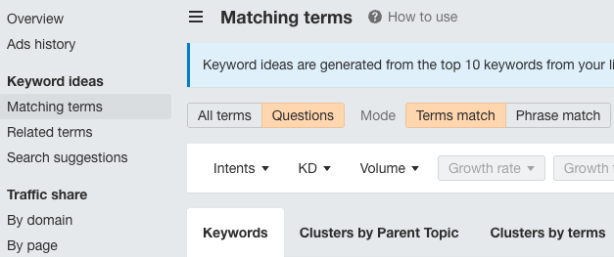

Related tab
Click on the “related” tab and export these terms.

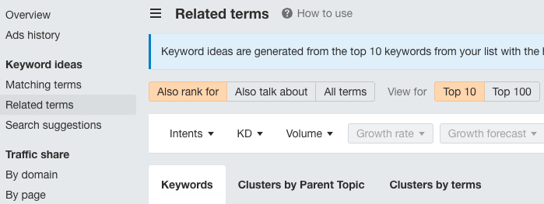

Step 5: Analysing terms & using filters

On any of the tabs, click the cell/block (see red dot) between the first row (1) and the first column (A) to select all cells.

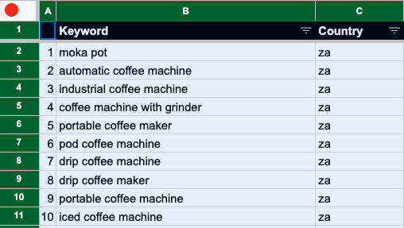

Then navigate to the “data”, “create a filter”.

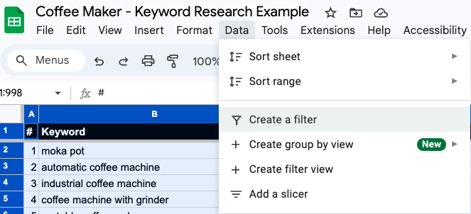

Then click the three lines/filter icon to apply specific filters:

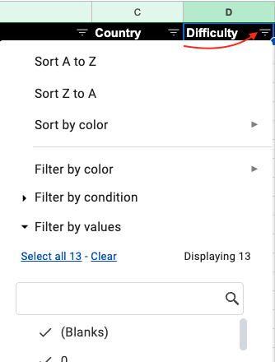

For example:
- If you apply the “sort by A to Z” filter for the keyword difficulty column, you can see keywords with the lowest difficulty score.
- If you apply “sort by Z to A” for the difficulty column, you can see keywords with the highest difficulty score.
- If you click the dropdown “Filter by condition”, you can use filters like “text contains” or “text does not contain” to include or exclude certain terms/cells.

There are lots of ways you can utilise filters, but always keep the purpose behind why you are applying a filter top of mind (i.e, whether you are trying to narrow your search around a specific query, or find specific opportunities like low-hanging fruit).

Step 6: Exporting SERP examples for focus terms

It can be helpful to export the Search Engine Results Page for the main one or two keywords that you are targeting in order to better understand your competition and the potential for your piece of content.

Let’s say that you are creating a landing page that will target the keyword “coffee machine with grinder”. Enter this term in Keywords Explorer, scroll down and click the export button next to the SERP section of the report (see screenshot below).

Import and append the data to the SERP tab in your sheet for further analysis.

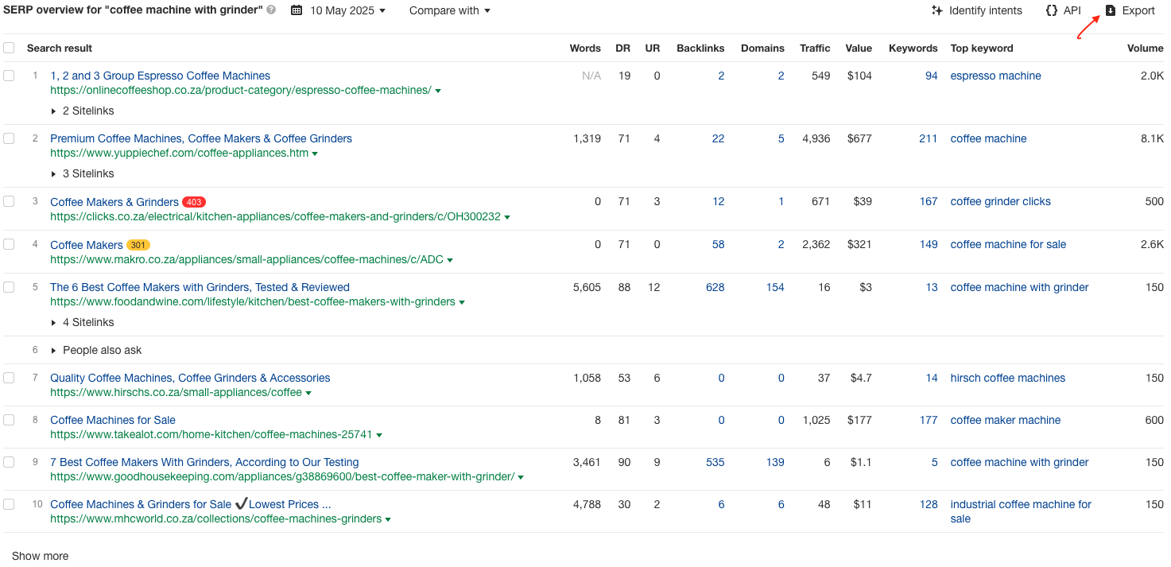

From here, you can look at the columns to better understand your competitors for this keyword, for example:

- Domain Rating: Consider the lowest, highest and typical domain ratings of the websites ranking for your term. You can compare this with your site/client’s domain rating to inform your decision-making (to see whether they are likely to compete with other top results for a given query).
- Traffic: You can use this column to see the estimated monthly organic traffic that each search result receives across all its ranking keywords.This may give you an indication of potential traffic for the page you’re creating.
- Keywords: You can use this column to see the number of keywords a result ranks for in the top 100 positions. You can click the number of keywords to see the terms a page is ranking for. This may give you an indication of the number of keywords you may be able to rank while also considering how your content will measure up to competitors.
- Backlinks: You can use the backlinks column to see the number of links from other domains pointing to a search result. This may help you understand the difficulty and the extent of link-building efforts required to compete for more competitive terms.
- Top Keyword: To see the keyword that brings the most organic traffic to a search result.
- Words: Looks at the total number of words present in the HTML of a web page for a given search result. This data can be prone to inaccuracies, so it is always best to actually visit the landing page for a given result to double-check the content length. However, this can give you a rough indication of how long your content needs to be to compete.

Step 7: Peer review of keyword research during the outline review phase

Once you’ve exported the keyword data and completed the content outline for your blog post or landing page, attach the keyword research sheet to the document you’ve created.

During the outline review phase, the peer reviewer will evaluate the content approach and the keyword research.

End of SOP

Additional or related sources:

- Setting up a Surfer credit - SOP pending completion; web article here
  - While SurferSEO's Content Editor allows you to input up to 20 keywords per article, it's advisable to concentrate on a primary keyword along with a few closely related secondary keywords. This strategy helps maintain content quality and relevance, avoiding the pitfalls of keyword stuffing or diluting the main topic.
- Utilising the keyword mapping template for landing pages - SOP pending completion.
- Utilising the keyword mapping template for blog posts - SOP pending completion.

